**Solution:** using System;

namespace Abdul_wahab

{

class Program

{

static void Main(string[] args)

{

Console.WriteLine("Enter no of rows of Matrix 1"); int R1 = int.Parse(Console.ReadLine()); Console.WriteLine("Enter no of columns of Matrix 1"); int C1 = int.Parse(Console.ReadLine());

int[,] mat1 = new int[R1, C1];

Console.WriteLine("Enter elements of matrix 1 row by row"); for (int i = 0; i < R1; i++)

{

for (int j = 0; j < C1; j++)

{

mat1[i, j] = int.Parse(Console.ReadLine());

}

}

Console.WriteLine("Enter no of rows of Matrix 2"); int R2 = int.Parse(Console.ReadLine()); Console.WriteLine("Enter no of columns of Matrix 2"); int C2 = int.Parse(Console.ReadLine());

int[,] mat2 = new int[R2, C2];

Console.WriteLine("Enter elements of matrix 1 row by row"); for (int i = 0; i < R2; i++)

{

for (int j = 0; j < C2; j++)

{

mat2[i, j] = int.Parse(Console.ReadLine());

}

}

Console.WriteLine("Matrix 1 ="); for (int i = 0; i < R1; i++)

{

for (int j = 0; j < C1; j++)

{

Console.Write("{0,4}", mat1[i, j]);

}

Console.WriteLine();

}

Console.WriteLine("Matrix 2 ="); for (int i = 0; i < R2; i++)

{

for (int j = 0; j < C2; j++)

{

Console.Write("{0,4}", mat2[i, j]);

}

Console.WriteLine();

}

if (C1 == R2)

{

int[,] mat3 = new int[R1, C2]; for (int i = 0;

i < R1; i++)

{

for (int j = 0; j < C2; j++)

{

mat3[i, j] = 0;

for (int k = 0; k < C1; k++)

{

mat3[i, j] = mat3[i, j] + mat1[i, k] * mat2[k, j];

}

}

}

Console.WriteLine("Matrix 1 x Matrix 2 = "); for (int i = 0; i < R1; i++)

{

for (int j = 0; j < C2; j++)

{

Console.Write("{0,4}", mat3[i, j]);

}

Console.WriteLine();

}

}

else

{

Console.WriteLine("Multiplication is not possible");

}

}

}

}

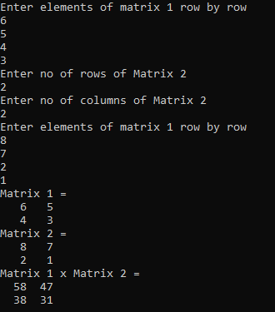

**TASK 02:** **Take N number of user data input and make sure N is greater than 10, which contain name of the user, his/her nationality and his/her eye color. You have to show the max.**

**Solution:**

using System;

namespace ConsoleApp44

{

class Program

{

static void Main(string[] args)

{

Console.WriteLine("Enter number of users");

int n = int.Parse(Console.ReadLine());

int C = 3;

string[,] a = new string[n, C];

a[0, 0] = "Name";

a[0, 1] = "Nationality";

a[0, 2] = "Eye Color";

int brown = 0, green = 0, black = 0, grey = 0, blue = 0;

for (int i = 0; i < n; i++)

{

for (int j = 0; j < C; j++)

{

if (i != 0 && j == 0)

{

Console.WriteLine("Enter Name {0}", i);

a[i, j] = Console.ReadLine();

}

if (i != 0 && j == 1)

{

Console.WriteLine("Enter Nationality {0}", i);

a[i, j] = Console.ReadLine();

}

if (i != 0 && j == 2)

{

Console.WriteLine("Enter EyeColor {0}", i);

a[i, j] = Console.ReadLine();

if (a[i, j] == "Brown" || a[i, j] == "brown")

{

brown++;

}

if (a[i, j] == "Green" || a[i, j] == "green")

{

green++;

}

if (a[i, j] == "Black" || a[i, j] == "black")

{

black++;

}

if (a[i, j] == "Grey" || a[i, j] == "grey")

{

grey++;

}

if (a[i, j] == "Blue" || a[i, j] == "blue")

{

blue++;

}

}

}

}

Console.Clear();

for (int i = 0; i < n; i++)

{

for (int j = 0; j < C; j++)

{

Console.Write("{0,16} ", a[i, j]);

}

Console.WriteLine();

}

Console.WriteLine("Total Brown eyes = {0}", brown);

Console.WriteLine("Total Green eyes = {0}", green);

Console.WriteLine("Total Black eyes = {0}", black);

Console.WriteLine("Total Grey eyes = {0}", grey);

Console.WriteLine("Total Blue eyes = {0}", blue);

}

}

}

**Output:**

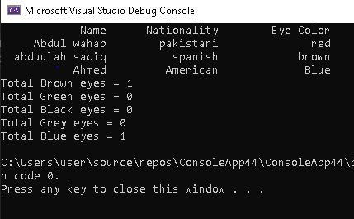

TASK 03:

using System;

namespace Abdul-wahab

{

class Program

{

static void Main(string[] args)

{

int n, total = 0;

double d = 1, dtotal = 0; Console.WriteLine("Enter No. of items:"); n = int.Parse(Console.ReadLine()); string[,] item = new string[n, 3];

for (int x = 0; x < n; x++)

{

Console.WriteLine("\nEnter name of item {0}:", x + 1); item[x, 0] = Console.ReadLine();

if (item[x, 0] == "rice" || item[x, 0] == "Rice")

{

d = 0.7;

}

Console.WriteLine("\nEnter price of {0} :", item[x, 0]); item[x, 1] = Console.ReadLine();

Console.WriteLine("\nEnter quantity of {0} :", item[x, 0]); item[x, 2] = Console.ReadLine();

total += (int.Parse(item[x, 1]) * int.Parse(item[x, 2]));

}

if (d != 0.7)

{

if (total >= 50000 & total <= 100000)

{

d = 0.8;

}

else if (total > 100000)

{

d = 0.7;

}

}

dtotal = total * d;

Console.WriteLine("S.no\t\tItem name\tPrice\t\tQuantity\n"); for (int x = 0; x < n; x++)

{

Console.Write("{0}", x + 1); for (int y = 0; y < 3; y++)

{

if (y == 1)

{

}

else

{

}

}

Console.Write("\t\t${0}", item[x, y]);

Console.Write("\t\t" + item[x, y]);

Console.WriteLine();

}

Console.WriteLine("\n\tTotal : {0:c}", total); if (d != 1)

{

Console.WriteLine("\n\tTotal after discount of {0:0.00}% is : {1:c}", (1 - d) * 100, dtotal);

}

}

}

}

# OUTPUT::

